ESS Section 3

Contents:

3. A/D and D/A Conversion Modeling
3.1 D/A Converter Modeling
3.2 A/D Converter Modeling
3.3 Miscellaneous 3.3.1 PWM DAC and ADC-Sampling Used For DCDCbuck Rev.10 and 11
3.3.2 Handling A/D and D/A Conversion within a Loop
3.3.3 Need for Synchronous Sampling
3.3.4 Limit Cycling
3.3.5 Describing Function

Procedure. In class, this MS Word document is written using a tablet PC. Page breaks and/or subsection headings can be moved. After class, students are offered both the modified Word document and a PDF printout of it.

A/D and D/A Converter Modeling

D/A Converter (DAC) Modeling

Conventional D/A Converter

Switch-Mode D/A Converter

A/D Converter (ADC) Modeling

Miscellaneous

PWM DAC and ADC-Sampling Used for DCDCbuck Rev.10 and 11
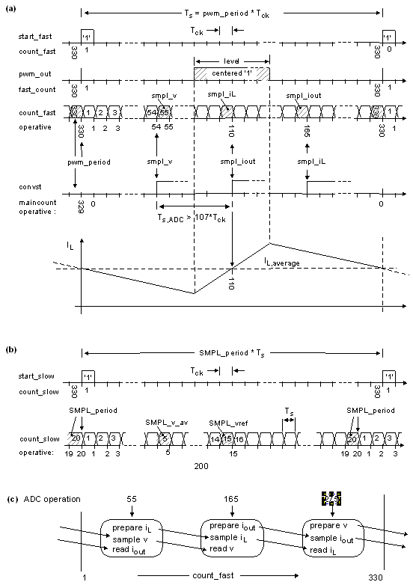
Fig. 3.3.1: Timing diagram with starting-'1' output, T_{ck} = 1 / f_{ck} = 1/ 50MHz. Sampling coil durrent I_{L} in the middle of the High- or Low-phase delivers its average value in CCM.

Handling A/D and D/A Conversion within a Loop

Need for Synchronous Sampling

Limit Cycling

Describing Function

References
- Linear Technology (today: Analog Devices), “Low Noise, 500ksps,
8-Channel, 12-Bit ADC”, available: https://www.analog.com/media/en/technical-documentation/data-sheets/2308fc.pdf

