**ESS Section 5**

**Contents:**

**5. Analog PID Controllers**

5.1 Locus of Poles and Stability

5.1.1 Linear Feedback-Loop Setup

5.1.2 Locus of System Poles and Closed-Loop Stability

5.1.3 Open-Loop Gain’s Phase Margin an Closed-Loop Stability

5.1.4 Impact of Delay

5.2 Passive Loop Gain Compensation

5.2.1 Stabilization by Lowering the Amplification

5.2.2 Stabilization by Adding a Low-Frequency Pole

5.2.3 Stabilization by Adding a Zero Onto the Cross-Over Frequency

5.2.4 Using Pole Splitting for Phase Margin Compensation

5.2.5 Lead-Lag Compensation

5.3 Active PID Loop Gain Compensation

5.3.1 Stabilization by an Active Differentiator

5.3.2 Compensation Using a Differentiator with Pole

5.3.2 Stabilization by Constant Gain

5.3.3 Advantages of an Integrator

5.4 Time-Continuous PID Compensation

5.4.1 Simplest *PID* Compensator Model

5.4.2 Compensation Using a Differentiator with Pole

5.4.3 *PID* Compensator Model with Pole *Tdp*

5.4.4 *PID* Compensator Model with Poles *ωip* and *Tdp*

5.4.5 *PID* Compensator Application to a DC/DC Buck Converter

**Procedure.** In class, this MS Word document is written using a tablet PC. Page breaks and/or subsection headings can be moved. After class, students are offered both the modified Word document and a PDF printout of it.

# Analog PID Controllers

### Linear Feedback-Loop Setup

|  |  |
| --- | --- |
| 1. Closed loop with error entry *E*. |  |
| 1. Opened loop and test signal feed-in *A*.  Here, phase margin *ΦM* must be measured against -360° = 0°,  as the inversion is part of the open loop now. |  |
| **Fig. 5.1.1:** Linear feedback loop systems | |

**Table 5.1.1:** Symbols, their acronyms and meanings, definitions, formulae

|  |  |  |  |
| --- | --- | --- | --- |
| **Signal** | **Significance** |  |  |
| *A* | test signal intput |  |  |
| *C* | Compensator output signal |  |  |
| *E* | Error entry |  |  |
| *ε* | Setpoint – actual value aberration |  |  |
| *P* | Plant/Process output signal |  |  |
| *V* | process variable |  |  |
| *X* | input signal |  |  |
| *Y* | output signal |  |  |
|  |  |  |  |
| **Symbol** | **Significance / Network Functionality** | **Definition** | **Formula** |
| *B* | feedBack network transfer function |  |  |
| *CTF* | Compensator Transfer Function |  | (typically PID) |
| *F* | Forward network transfer function |  |  |
| *FB, LG* | (open) Loop Gain |  |  |
| *NTF* | Noise Transfer Function |  |  |
| *PTF* | Plant/Process Transfer Function |  |  |
| *QTF* | Inference (Quarrel) input Transfer Function |  |  |
| *STF* | Signal Transfer Function |  |  |

### Locus of System Poles and Closed-Loop Stability



**Fig. 5.1.2** **(a)** Pole-paires of Closed-loop gain, **(b)** corresponding step responses.

The homogeneous system (i.e. without excitation) behaves according to

 ,

The second order system as a function cut-off frequency *ω0*, DC-amplification *A0* and damping constant *D*, is written with *S=s*/ω0 in a common form as

H(s) = $=\sum_{i=1}^{N}{a_{i}e^{s_{pi}t}}$ = = $=\sum_{i=1}^{N}{a_{i}e^{s_{pi}t}}$,

### Open-Loop Gain’s Phase Margin and Closed Loop Stability

|  |  |
| --- | --- |
| **Fig. 5.1.2.1:**  Frequency compensaton by setting phase margin to φM≥45°:   1. Amplitude diagram with (dashed) and without (solid line) compensation. 2. Phase diagram with (dashed) and without (solid line) compensation. |  |



**Simulation example with 45° phase margin**

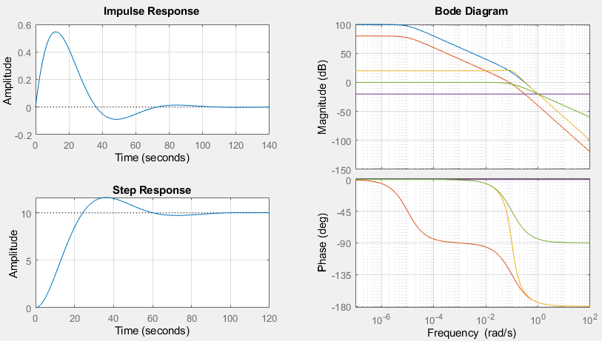

**Fig. 5.1.2.2** : Compensation goal: the second pole, here named *ωp1*, is placed onto cross-over frequency *ωx1* of open-loop gain *FB1*, to yield phase margin of ΦM = 45°. Figure parts:   
upper left: impulse response of *STF1*, lower left: step response of *STF1*,   
right: *Bode* diagram of blu: *F1*=*CTF1∙PTF1*, green: *CTF1*, pink: *B1*, yellow: *STF1*.

Fig. 5.1.2.2 generated by the code in listing 5.1.2.2 illustrates a *Matlab* simulation of 2nd-order system with the 2nd pole, here named *ωp1*, is placed onto cross-over frequency *ωx1* of the open-loop gain *FB1*, to yield phase margin of ΦM = 45°.

**Listing 5.1.2.2**: generates Matlab plot Fig. 5.1.2.2

%% 1st order system

b1 = 0.1; % feedback network as constant factor

B1 = tf(b1); % feedback network as transfer function

wx1 = 0.1; % cross-over frequency of FB1 without compensation

wcp = wx1; % pole to be set

CTF1 = tf([1],[1/wcp 1]); % set a pole at wcp

A1 =1e5; wp1=1e-5; % DC amplification and 1. pole of plant

PTF1 = tf([A1*wp1],[1 wp1]); % plant / process transfer function

F1 = CTF1*PTF1; % total forward network

FB1 = F1*B1; % open loop gain

STF1 = feedback(F1,B1); % signal transfer function of the closed loop

figure(1); % 1st order sysmtem's graphical postprocessing > figure 1

subplot(221); impulse(STF1); grid on;

subplot(223); step(STF1); grid on;

subplot(122); bodeplot(F1,FB1,STF1,B1,CTF1); grid on;

xlim([1e-7 1e2]);

### The Impact of Delay

A delay ***Tdel* in time domain** translates to phase shift **Φ*del* = ‑ ω∙*Tdel* in frequency** domain:

 ⬄ 

with *FT* symbolizing the fourier transform. Proof using *τ = t – T*  ⬄ d*τ*/d*t* = 1 ⬄ d*t* = d*τ* :



This is a linar phase response:

At cross-over frequency *ωx* , marked by unitiy loop-gain |*FB*(*ωx*)| = 1, this delay causes a phase margin loss of

.

On a logharithmic frequency axis the phase loss *Φdel* seems to behave exponential.

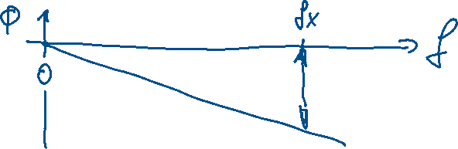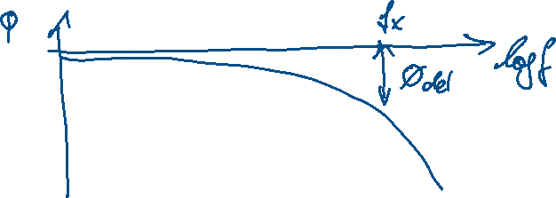

## Passive Loop Gain Compensation Techniques

### Stabilization by Lowering the Amplification



### Stabilization by Adding a Low-Frequency Pole

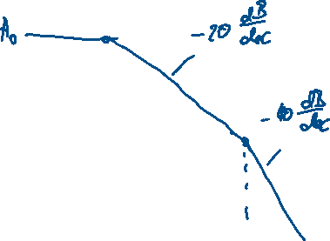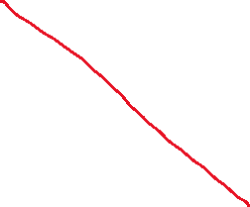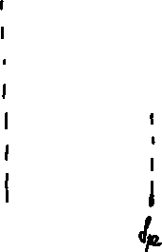

### Stabilization by Adding a Zero Onto the Cross-Over Frequency



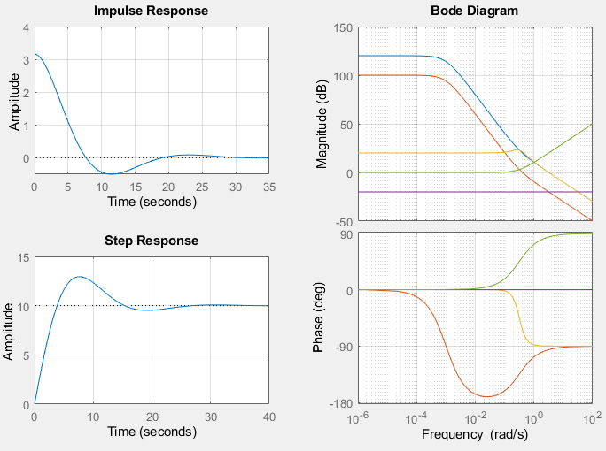

**Fig. 5.2.2** : setting a zero *ωn2* at *ωx2*:   
upper left: impulse response of *STF2*, lower left: step response of *STF2*,   
right: *Bode* diagram of blu: *F2*=*CTF2∙PTF2*, green: *CTF2*, pink: *B2*, yellow: *STF2*.

Fig. 5.2.2 generated by the code in listing 5.2.1 illustrates a *Matlab* simulation of introducing a pole on the cross-over frequency *ωx2*.

**Listing 5.2.2**: generates Matlab plot Fig. 45.4.2.2

%% 2nd order system

b2 = 0.1; % feedback network as constant factor

B2 = tf(b2); % feedback network as transfer function

wx2 = sqrt(b2); % cross-over frequency of FB2 without compensation

wcn = wx2; % zero to be set

CTF2 = tf([1/wcn 1],[1]); % set a zero at wcn

A2 = 1e6; wp2=1e-3; D2=1; % DC ampl., double-pole, damp. const. of plant

PTF2 = tf([A2*wp2*wp2],[1 2*D2*wp2 wp2^2]);

F2 = CTF2*PTF2; % total forward network

FB2 = F2*B2; % open loop gain

STF2 = feedback(F2,B2); % signal transfer function of the closed loop

figure(2); % 2nd order sysmtem's graphical postprocessing > figure 2

subplot(221); impulse(STF2); grid on; %upper left quarter: impulse response

subplot(223); step(STF2); grid on; %lower left quarter: step response

subplot(122); bode(F2,FB2,STF2,B2,CTF2); grid on; % right half: Bode diag.

xlim([1e-6 1e2]); % set abscissa range

### Using Pole Splitting for Phase Margin Compensation



### Lead-Lag Compensation

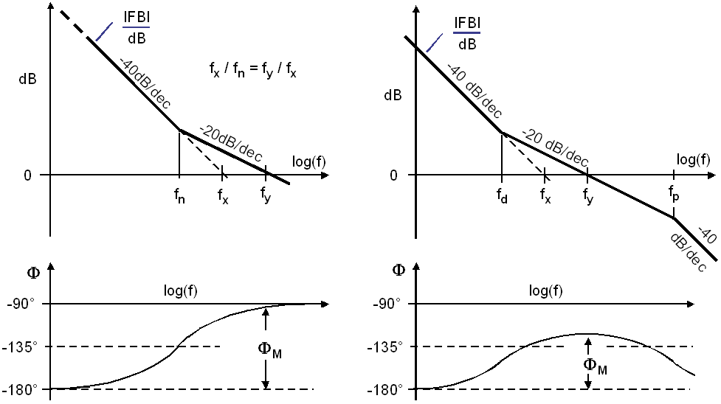

**Fig. 5.2.4.1** **(a)** introducing a zero at *fn = fx / a*, **(b)**  zero at *fdn = fx / a* and pole at *fdp = fx∙a3.*

Figure part (a) uses a single zero to stabilize a 2nd order system with uncompensated and compensated cross-over frequencies *fx* and *fy*, respectively. For *a* > 1 we get *fn∙a = fx =fy / a*.

Figure part (b) uses a lead-lag compensator to stabilize a 2nd order system with uncompensated and compensated cross-over frequencies *fx* and *fy*, respectively. For *a* > 1 delivers *fy = a∙fx* with zero-pole pair *fdn∙a2 = fy =fdp / a2*, corresponding to *fdn∙a = fx =fdp / a3*.

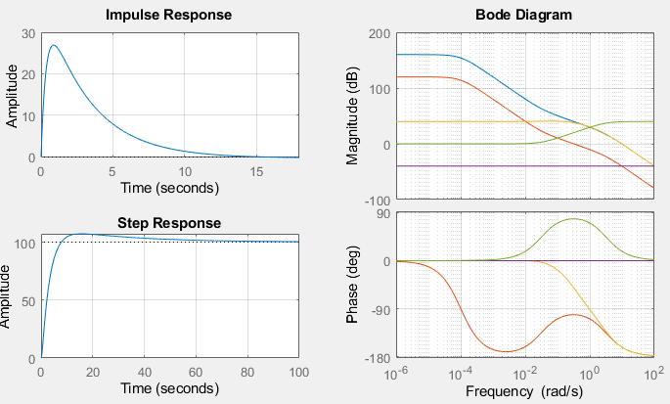

**Fig. 5.2.4.2** : introducing a zero at *ωcn = ωx3 / a3* and pole at *ωcp = ωx3∙*(*a3*)*3* with *a*=sqrt(10):   
upper left: impulse response of *STF3*, lower left: step response of *STF3*,   
right: Bode diagram of blu: *F3*=*CTF3∙PTF3*, green: *CTF3*, pink: *B3*, yellow: *STF3*.

Fig. 5.2.4.2 generated by the code in listing 5.2.4.2 illustrates a *Matlab* simulation of introducing a lead-lag element around the cross-over frequency *ωx3*.

**Listing 5.2.4.2**: generates Matlab plot Fig. 5.2.4.2

%% Lead-Lag Element in 2nd order system

b3 = 0.01; % feedback network as constant factor

B3 = tf(b3); % feedback network as transfer function

wx3 = sqrt(b3); % cross-over frequency of FB2 without compensation

a3 = sqrt(10); % user's choice to set a3 | sqrt(10) > 7% volt. overshoot

wcn = wx3/a3; % zero to be set

wcp = wx3*a3^3; % zero to be set

CTF3 = tf([1/wcn 1],[1/wcp 1]); % lead-lag: set zero at wcn and pole at wcp

A3 = 1e8; wp3=1e-4; D3=1; % DC ampl., double-pole, damp. const. of plant

PTF3 = tf([A3*wp3*wp3],[1 2*D3*wp3 wp3^2]);

F3 = CTF3*PTF3; % total forward network

FB3 = F3*B3; % open loop gain

STF3 = feedback(F3,B3); % signal transfer function of the closed loop

figure(3); % 2nd order sysmtem's graphical postprocessing > figure 2

subplot(221); impulse(STF3); grid on; %upper left quarter: impulse response

subplot(223); step(STF3); grid on; %lower left quarter: step response

subplot(122); bode(F3,FB3,STF3,B3,CTF3); grid on; % right half: Bode diag.

xlim([1e-6 1e2]); % set abscissa range

## Active PID Loop Gain Compensation

### Stabilization by an Active Differentiator

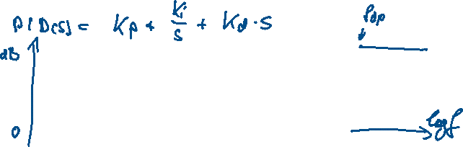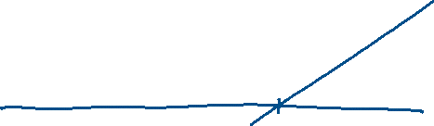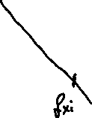

### Compensation Using a Differentiator with Pole



### Stabilization by Constant Gain

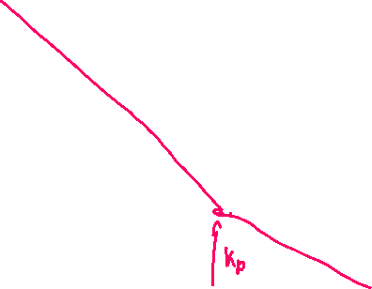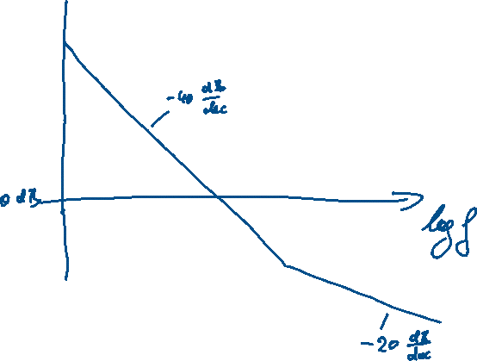

### Advantages of an Integrator

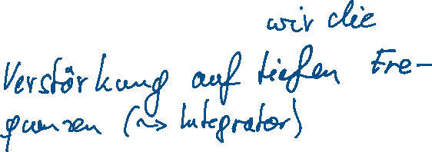

## Time-Continuous PID Compensation

### Simplest *PID* Compensator Model

The most simple PID compensator model delivers



and on a single fraction bar



Disadvantages are stability problems and the fact, that numerator order > denominator order is not possible, the system was non-causal and would deliver infinite amplification for infinite frequencies.

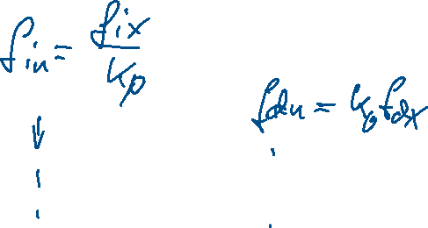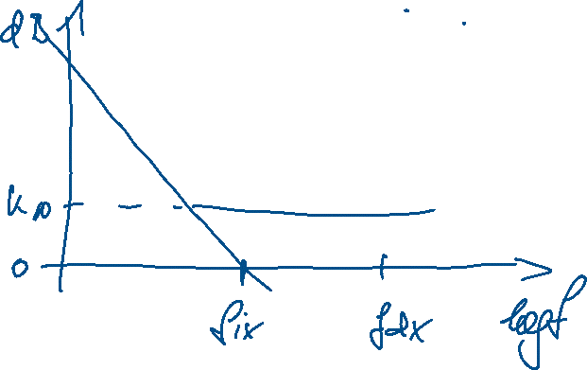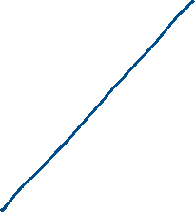

### *PID* Compensator Model with Pole *Tdp*

Typically, we find a mathematical model of the form

,

which delivers on a single fraction bar

.

Relationships to *Matlab / Simulink* control parameters *P, I, D, N* are:

|  |  |  |  |
| --- | --- | --- | --- |
|  |  |  |  |

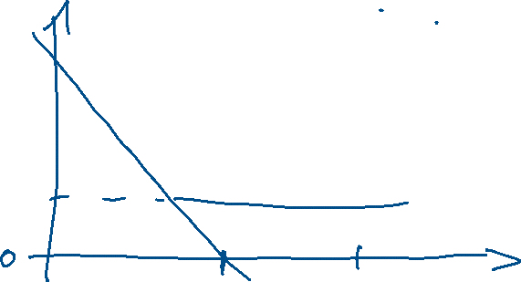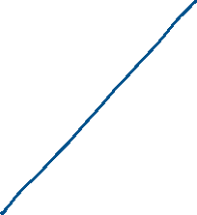

### *PID* Compensator Model with Poles *ωni* and *Tdp*

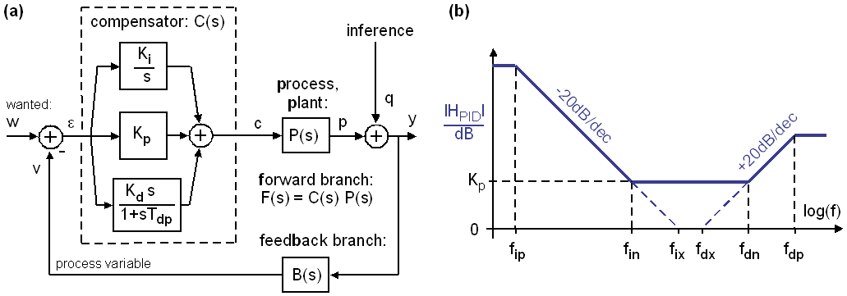

**Fig. 5.4.3:** PID Compensator, **(a)** topology and **(b)** asymptotic Bode diagram

Although mathematical models typically use *ωip* = 0, a finite *ωip* > 0 is inevitable for analog amplifiers, and in the digital domain the range of representable numbers is limited. The three-term model



delivers on a single fraction bar



which represents the 2nd order LTI system



with coefficients

|  |  |  |
| --- | --- | --- |
|  |  |  |
|  |  |  |

Relationships between PID parameters and corner frequencies in Fig. part (b) are

|  |  |  |  |
| --- | --- | --- | --- |
|  |  |  |  |

Relationships to *Matlab / Simulink* control parameters P, I, D, N are:

|  |  |  |  |
| --- | --- | --- | --- |
|  |  |  |  |

### *PID* Compensator Application to a DC/DC Buck Converter

**(a)** red: TF of RLC lowpass, black target loop gain, **(b)** same as (a), illustrate compensator

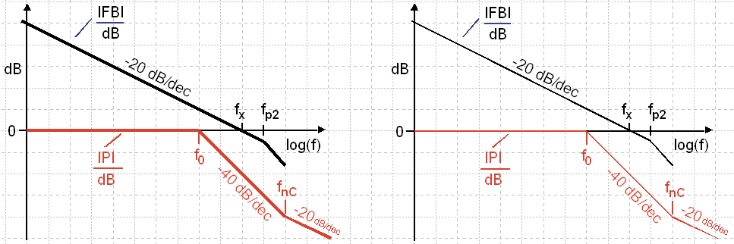

**Fig. 5.4.4:** PID Compensator, **(a)** target loop-gain, **(b)** illustrate compensator asymptotes

# References

1. *Wikipedia, Phase margin, available: https://en.wikipedia.org/wiki/Phase_margin*