**ESS Section 3**

**Contents:**

**3. A/D and D/A Conversion Modeling**

3.1 D/A Converter Modeling

3.2 A/D Converter Modeling

3.3 Miscellaneous 3.3.1 PWM DAC and ADC-Sampling Used For *DCDCbuck Rev*.10 and 11

3.3.2 Handling A/D and D/A Conversion within a Loop

3.3.3 Need for Synchronous Sampling

3.3.4 Limit Cycling

3.3.5 Describing Function

**Procedure.** In class, this MS Word document is written using a tablet PC. Page breaks and/or subsection headings can be moved. After class, students are offered both the modified Word document and a PDF printout of it.

# A/D and D/A Converter Modeling

## D/A Converter (DAC) Modeling

### Conventional D/A Converter

### Switch-Mode D/A Converter

## A/D Converter (ADC) Modeling

## Miscellaneous

### PWM DAC and ADC-Sampling Used for *DCDCbuck Rev*.10 and 11

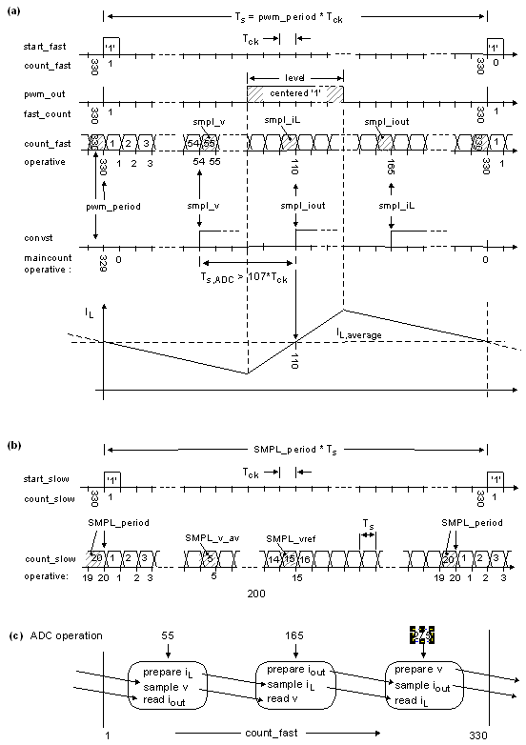

**Fig. 3.3.1:** Timing diagram with starting-'1' output, *Tck* = 1 / *fck* = 1/ 50MHz. Sampling coil durrent *IL* in the middle of the High- or Low-phase delivers its average value in CCM.

### Handling A/D and D/A Conversion within a Loop

### Need for Synchronous Sampling

### Limit Cycling

### Describing Function

## References

1. *Linear Technology (today: Analog Devices)*, “*Low Noise, 500ksps,  
   8-Channel, 12-Bit ADC*”, available: https://www.analog.com/media/en/technical-documentation/data-sheets/2308fc.pdf