**ESS Section 2**

**Contents:**

**2. Main Example: A Switch-Mode Converter**

2.1 Switch-Mode Converter 2.1.1 Step-Down (Buck) Converter 2.1.1.1 Not Switching: Low Drop-Out Regulartors (LDOs)

2.1.1.2 Switch-Mode Buck Converter in Synchronous Operation

2.1.1.3 Asynchronously Operating Buck Converter

2.1.1.4 Continuous Conduction Mode (*CCM*)

2.1.1.5 Discontinuous Conduction Mode (*DCM*)

2.1.2 Step-Up (Boost) Converter

2.1.3 Combined Boost / Buck Converter

2.1.4 DC/DC Inverter

2.1.5 Converter Principle Summary

2.2 Building Blocks 2.2.1 Power-Switching Unit

2.2.2 RLC Lowpass

2.2.3 DC/DC Control Modes 2.2.3.1 Voltage Mode Control

2.2.3.2 Cutrrent Mode Control

2.2.3.3 Active Voltage Positioning (deutsch: Lastaufschaltung)

2.2.4 A/D and D/A Converter 3.3.4.1 A/D Converter (*ADC*)

3.3.4.1 D/A Converter (*DAC*): PWM

2.3 DCDCbuck_Rev10.02 2.3.1 Design Discussion 2.3.1.1 Schematics of DCDCbuck_Rev10.02.06 (Eagle)

2.3.1.2 Layout of DCDCbuck_Rev10.02.06 (Eagle)

2.3.1.3 Synchronous/Asynchronous Switch

2.3.1.4 Load Current Circuit and Switch

2.3.1.5 Charge-Pump for High-Side Power-N- MOSFET

2.3.1.6 Current Sensor Circuits

2.3.1.7 Average Output Voltage Determination

2.3.1.8 ADC Input Plug

# Main Example: A Switch-Mode Step-Down Converter

## Switch-Mode Converter

### Step-Down (Buck) Converter

#### Non Switching: Low Drop-Out Regulators (LDOs) *)



**Fig. 2.1.1.1-1:** Bipolar power transsitors of low drop-out voltage regulators (*LDOs*).

* Motivation for switching: High power dissipation of a not switching sources
* The voltage difference from input to output voltage is dissipated to heat.
* Power dissipation: *Pdiss = Udo ∙ Iout*, with *Udo* drop-out voltage, *Iout* output current.

|  |  |
| --- | --- |
| Figure 2.1.1.1-2 shows typical LED circuits. The resistor used as a current source in (a) is susceptible to fluctuating supply voltages. The current source in (b) has a higher resistance but is just as inefficient.  Example: *VCC*=12V, *UF*=3V. The power dissipated by the (a) resistor and (b) current regulator, calculated as (*VCC‑UF*)·*ID* = 9V·*ID*, is 3x higher than *UF*·*ID* = 3V·*ID*, the power dissipated by the light-emitting diode. | **Fig. 2.1.1.1‑2:** most power dissipated in  (a) resistor *R* and (b) BJT |

|  |  |  |  |  |  |  |  |  |  |  |  |  |  |  |  |  |  |  |  |  |  |
| --- | --- | --- | --- | --- | --- | --- | --- | --- | --- | --- | --- | --- | --- | --- | --- | --- | --- | --- | --- | --- | --- |
| |  |  |  |  | | --- | --- | --- | --- | | LED-current/A | UF,min / V | UF,typ / V | UF,max / V | | 0,2 | 2,68 | 3,27 | 3,77 | | 0,35 | 2,79 | 3,42 | 3,99 | | 0,7 | 3,05 | 3,76 | 4,47 | | 1 | 3,16 | 3,95 | 4,88 |   **Fig. 2.1.1.1‑3:** Forward voltages of a white high-current LED for automotive applications [leds]. |  |

*) not relevant to the exam

#### Switch-Mode Buck Converter in Synchronous Operation

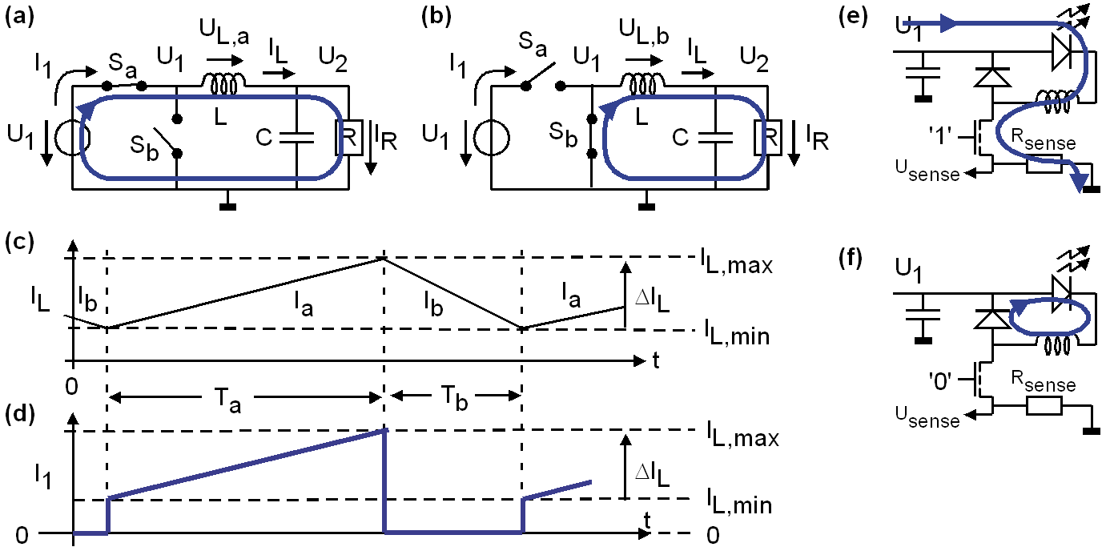

|  |  |
| --- | --- |
| **Fig. 2.1.1.2 :** DC/DC buck converter. (a), (b): Operation mode is synchronous due to the existence of switch *Sb* instead of a diode. (e), (f): asynchronous due to diode.  Switch *Sa* is   1. for period *Ta* ideally conducting and 2. for period *Tb* isolating. *Sb* operates inverted to *Sa*. | (g) Spikes as switching noise due to high d*I1*/d*t*. |

Motivation for swith mode operation: high efficiency! Power dissipated in a switch, *PV = US · IS*, is is 0 if either *US*=0V or *IS*=0A! We seek to switch between these two states.

***U2 = D U1*** with duty cycle ***D=Ta*/(*Ta+Tb*)**, assuming *U1*, *U2*, *Iout* settled and constant.

* Theoretically achievable efficiency 100%.
* In practice, 90% is good, 94...96% is difficult. See for example Figs. 9_6 and 9_19 at pages 41 and 42, respectively, of the *LM25149* datasheet [LM25149] [<https://www.ti.com/lit/ds/symlink/lm25149.pdf?ts=1660045466006>]

Discussion of Fig. 2.1.1.2

1. In part (a) the inductance *L* is charged. It should be noted that the charging time must be limited, because otherwise the current grows into infinity.
2. In part (b) of the picture, inductance *L* discharges its energy to the secondary circuit.
3. Part (e) of the figure illustrates the current through the inductor *L*. It must be continuous
4. Part (d) shows the current through the voltage source *U1*. It shows current jumps that cause a lot of problems, e.g. the switching-noise glitches in Fig. part (g).
5. Part (e) shows how to operate a light emitting diode (LED) using asynchronous operation,
6. Part (f): same circuit like (e) but switching MOSFET (corresponding to *Sa*) is OFF and the current flows over a diode replacing switch *Sb* of the synchronous circuit.

Practical hint: The DC current through inductance *L* may rise to high values. All wires that have to carry this high current, must be designed accordingly.

#### Switch-Mode Buck Converter in Asynchronous Operation

|  |  |
| --- | --- |
| **Fig. 2.1.1.3**  With diode *D*: asynchronous.   1. charging, 2. discharging   inductor *L* with energy. |  |

Fig. 2.1.1.3 illustrates a DC/DC buck converter in asynchronous operation mode, as switch *Sb* of Fig. 2.1.1.2 is replaced by a diode. Typically Schottky diodes are used for this purpose due to their lower forward voltage of 0.4-0.5V, wich is some 0.2V less than a silicon diode. This is simpler than synchronous operation, but the voltage drop across diode *D* causes a power loss of *UD∙IL* when switch S is open.

#### Continuous Conduction Mode (CCM)

Inductor current *IL* never remains at zero.

Inductor current *IL* always positive: desired operation mode!

If inductor current *IL* becomes temporarily negative: inefficient!

#### Discontinuous Conduction Mode (*DCM*)

* Deutsch: lückender Betrieb.
* For the period of reverse voltage across diode *D* the inductor current *IL* remains at zero.
* *DEM*: **d**iode **e**mulation **m**ode in sync. circuits: switch *Sb* is operated to work like a diode, conducing forward current only. Advantage: flow voltage << the 0.5V of a *Schottky* diode.

**Things to do: we need to implement DEM and calculate the average coil current!!!**

### Step-Up (Boost) Converter *)

|  |  |
| --- | --- |
| **Fig. 2.1.2:** Boost   1. Load *IL* into *L* 2. *IL* charges *C* 3. Current for constant *U1*, *U2* |  |

***U2 = U1*** / (1‑***D***) with duty cycle ***D=Ta*/(*Ta+Tb*)**, assuming *U1*, *U2*, *Iout* settled and constant.

### Combined Boost / Buck Converter

|  |  |
| --- | --- |
| **Fig. 2.1.3:** Combined Boost/Buck converter. |  |

In the case of the combined boost/buck converter of Fig. 2.1.3, the boost converter prevents the source *U1* from being disturbed by the extreme current slopes d*I1*/d*t* of the buck part, which adjusts the output current to the load, e.g. LEDs for automotive applications.

*) not relevant to the exam

### DC/DC Inverter *)

|  |  |
| --- | --- |
|  | |
| **Fig. 2.1.4:**   1. Loading *L*, 2. unloadng *L*, 3. *IL=I*(*L*), 4. *I1=I*(*U1*). |  |

***U2 = - U1*** ∙ *Ta / Tb*, assuming *U1*, *U2*, *Iout* settled and constant.

Application example: Given is a voltage supply of *VCC*=5V and 0V. Required is ‑5V.

Industial example: TPS63700 [TPS63700]. [<https://www.ti.com/lit/ds/slvs530b/slvs530b.pdf?ts=1660013549556>].

### Converter Principle Summary *)

|  |  |
| --- | --- |
| **Fig. 2.1.5:**  DC/DC converter principles:   1. Step-up (boost) converter 2. Step-down (buck) converter 3. Inverter |  |

## Building Blocks

### Power-Switching Unit

The power-switching unit is the kernel element of switch-mode converters. It consists of a high-side switch and a low side switch (synchronous operation) or diode (asynchronous operation).

The power dissipated in a switch in *PV = US ∙ IS*. Consequently, we seek to achieve values near zero for either *US* or *IS*.

Due to ca. 3x higher mobility of electrons compared to holes, the high-side switch is frequently made up of an N-channel MOSFET, which typically needs a charge-pump the achieve sufficiently high gate voltages.

Fig 2.2.1 illustrates the principle of the charge pump: Charge bootstrap capacitor *Cboot* when *PWMout* = '0'. Pump charge up when *PWMout* goes '1'.

Constraints:

* *PWMout* **must** toggle, otherwise the charge pump can not operate → no 100% duty cycle!
* '0'-phase long enough to charge *Cboot*,
* '1'-phase long enough to not discharge *Cboot* below a certain level

**Fig 2.2.1(a):** Principle of switch-mode power conversion

**Fig 2.2.1(b):** Level shifter with charge pump and ***L****ow-side* ***S****witch* ***E****nable* (LSE) realization

**Fig 2.2.1(c):** PWM signal constraints

### *RLC* Lowpass

The pulse-widht modulator generates a pulse-width modulated (*PWM*) signal, which can be regarded as an average value plus harmonics. Problem A good lowpass (small losses) is also known as oscillator → good control unit (“frequency compensator”) required.

For our *DCDCbuck* boards, the PWM period consists of 330 clock cycles of the 50 MHz clock. Consequently, the PWM frequency is *fs* = 50 MHz / 330 = 151.5 KHz. The latter must be suppressed by the lowpass. Rule of thumb: The cut-off frequency of the lowpass should be ca. a factor 100 below the PWM frequency *fs* , consequently some 1 KHz.

Important corner frequencies:   1 KHz, , 

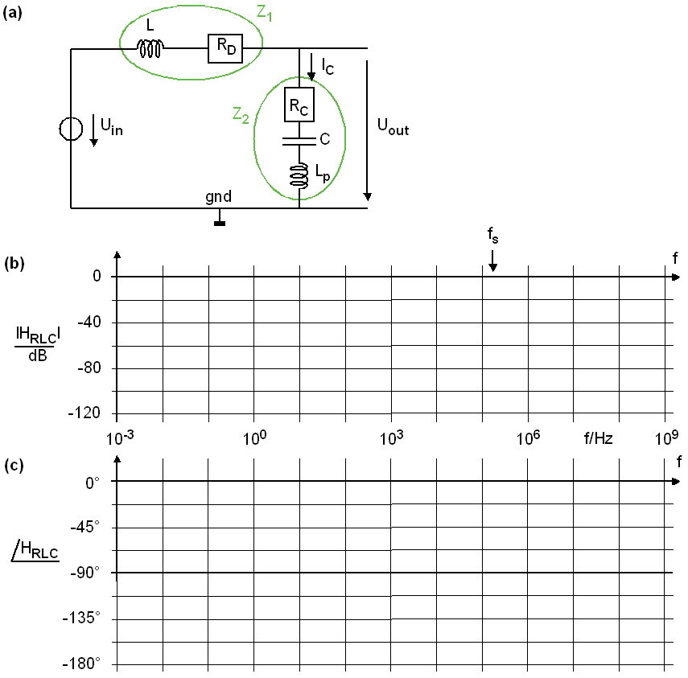

**Fig 2.2.2:** *RLC* lowpass as *PWM* demodulator

Let , ,

**Process or Plant Transfer Function:**



 = 

 = ,

 as ,

, 

|  |  |  |  |
| --- | --- | --- | --- |
| and | **1** | ***RC∙C*** | ***Lp∙C*** |
|  | **1** | **(*RC+RD*)*∙C*** | **(*L+Lp*)∙*C*** |

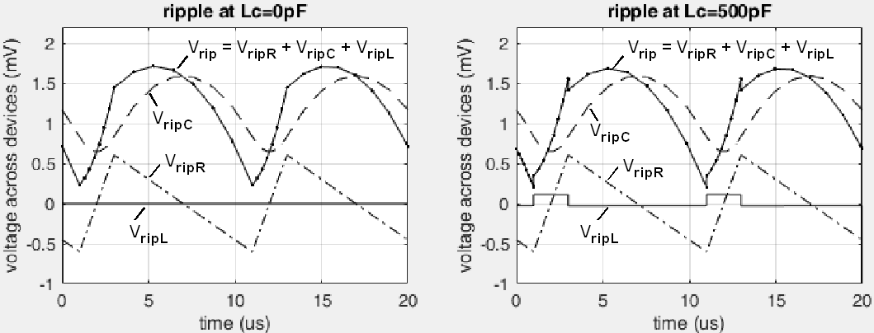

Left: Simulated ripple voltage for *fs = fnC* = 100 *f0* = 100 KHz, *D*=1/5, *L* = 43 μH, *C* = 589 μF, *RD* = 200mΩ, with parasitic inductor *LC* = 0 and right: *LC* = 500 pH

**Inference (or “Quarrel”) Transfer Function:**







= 

and

|  |  |  |  |
| --- | --- | --- | --- |
| ***RD*** | ***RC∙RD∙C + L*** | ***RD∙Lp∙C + RC∙L∙C*** | ***Lp∙L∙C*** |
| ***bp0*** | ***bp1*** | ***bp2*** | **0** |

*QTF*(*s*) has the physical dimension of an impedance and adds a zero *sn3 = ‑RD/L* to the *PTF*.

*QTF*(*s*) must have the same poles (and consequently the same coefficients) as the *PTF*, because *PTF*= *QTF* when *Uin = Iout* = 0.

**Matlab Model for Process and Inference Transfer Functions:**

% Model PTF and QTF of RLC lowpass

% --------------------------------

% whereas PTF(s) = (Uout/Uin) @ Iout=0: Plant Transfer Function,

% and QTF(s) = (Uout/Iout) @ Uin=0: Inference Transfer Func.

clear all;

L= 33e-6; RD=0.060; % main inductor + parasitic series resistor

C=100e-6; RC=0.080; Lp=500e-12; % main capacitor + parasitics

fg = 1/(2*pi*sqrt(L*C)); % approximative cutoff frequency

fnC = 1/(2*pi*RC*C); % approximative 1. zero of PTF + QTF

fnLp= RC/(2*pi*Lp); % approximative 2. zero of PTF + QTF

fqn3= RD/(2*pi*L); % approximative additional zero of QTF

% computation of PTF(s)

ap0=1; ap1=RC*C; ap2=Lp*C;

bp0=1; bp1=(RC+RD)*C; bp2=(L+Lp)*C;

% computation of QTF(s), model's bq3=0, but needs a value > 0

aq0=RD; aq1=RC*RD*C+L; aq2=RD*Lp*C+RC*L*C; aq3=Lp*L*C;

bq0=bp0; bq1=bp1; bq2=bp2; bq3=1e-14;

% computing accurately PTF's 1. and 2. zeros

spn1=-RC/(2*Lp)+sqrt((RC/(2*Lp))^2-1/(Lp*C));

spn2=-RC/(2*Lp)-sqrt((RC/(2*Lp))^2-1/(Lp*C));

fpn1=-spn1/(2*pi); % accurate 1. zero (compare to fnC)

fpn2=-spn2/(2*pi); % accurate 2. zero (compare to fnLp)

% computing accurately PTF's double pole (near cutoff freq. fg)

spp1=-(RC+RD)/(2*(L+Lp)) + sqrt(((RC+RD)/(2*(L+Lp)))^2 - 1/((L+Lp)*C));

spp2=-(RC+RD)/(2*(L+Lp)) - sqrt(((RC+RD)/(2*(L+Lp)))^2 - 1/((L+Lp)*C));

fpg = sqrt(abs(spp1*spp2))/(2*pi);

% implementing time-continuous transfer functions

PTF_s = tf([ap2 ap1 ap0],[bp2 bp1 bp0]);

QTF_s = tf([aq2 aq1 aq0],[bq2 bq1 bq0]);

figure(1);

o=bodeoptions; o.FreqUnits='Hz';

subplot(121);bodeplot(PTF_s,QTF_s,o); grid on;

subplot(222); step(PTF_s,QTF_s); grid on;

subplot(224); impulse(PTF_s,QTF_s); grid on;

### DC/DC Control Modes

#### Voltage Mode Control

A single controlled voltage source drives the RLC lowpass in a single loop: The PWM output is seen as a voltage source delivering an average value superimposed by higher frequencies that have to be removed by the RLC lowpass.

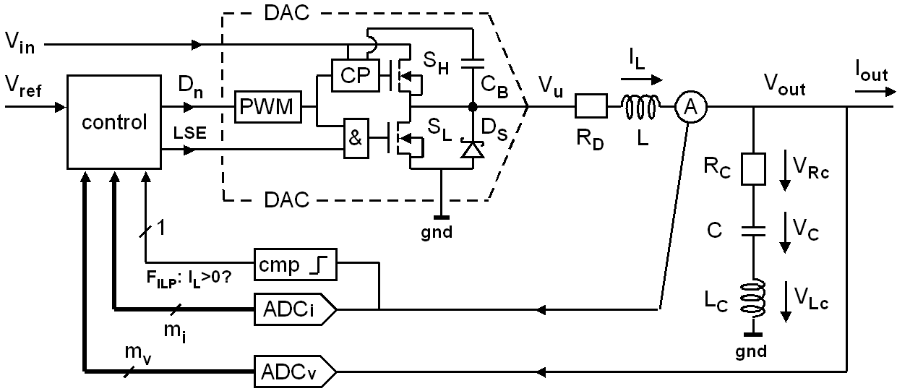

Typical DC/DC buck converter block diagram. *RC* and *LC* are unavoidable parasitics.

**Fig 2.2.3.1:** Voltage mode control: RLC low pass is driven as a single second order system

#### Current Mode Control

A controlled current source in the inner loop and a controlled voltage source in the outer loop:

The inductor is operated as current source,voltage source driving the RLC lowpass in a single loop: The PWM output is seen as a voltage source delivering an average value superimposed by higher frequencies that have to be removed by the RLC lowpass.

**Fig 2.2.2.2:** Current mode control: *L* operated as current source feeding *C* as 1st order system

#### Active Voltage Positioning (deutsch: Lastaufschaltung)

The output current is measured identically as coild current *IL*. It could be respected in the control to react faster, as it can do when it has to wait for an output voltage drop. This technique is particularly suitable for current mode control: If there is 1A more output current, we will have to feed the same amount of current into the coil.

[AVP] Robert Sheehan, “Active Voltage Positioning Reduces Output Capacitors”, available: https://www.analog.com/media/en/reference-design-documentation/design-notes/dn224f.pdf

### A/D and D/A Converter

#### A/D Converter (*ADC*)

The ADC *LTC2308* [LTC2308] is mounted on the *DE1-SoC* [DE1-SoC] board and features a sensitivity of 1bit/mV = 1000bit/V, an input range single ended and differential of 0…4095 or differential ‑2048…+2047.

[LTC2308] <https://www.analog.com/media/en/technical-documentation/data-sheets/2308fc.pdf>

[DE1-SoC] <https://www.terasic.com.tw/cgi-bin/page/archive.pl?Language=English&No=836>

#### D/A Converter (*DAC*): Pulse-Width Modulator (*PWM*)

## DCDCbuck_Rev10.02.06

### Design Discussion

#### Schematics of *DCDCbuck_Rev10.02.06* (*Eagle*)

|  |  |
| --- | --- |
| 1. Eagle [eagle] schematics, sheet 1 |  |
| 1. Eagle [eagle] schematics, sheet 2 |  |
| 1. Schematics   **Fig. 2.3.1.1:** *DCDCbuck Rev10.02.06* schematics |  |

#### Layout of *DCDCbuck_Rev10.02.06* (*Eagle*)

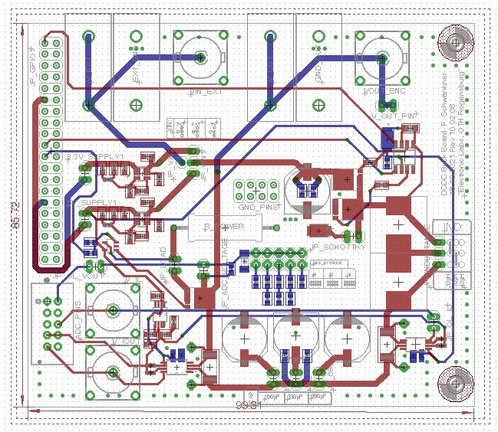

**Fig. 2.3.1.2:** *DCDCbuck Rev10.02.06* layout

#### Synchronous/Asynchronous Switch: *sw*(1)

*sw*(1) gates gate of low-side switch:

#### Load Current Circuit and Switch: *sw*(0)

#### Charge-Pump for High-Side Power-N-Channel MOSFET

Electrons have some 3x higher mobility in silicon than holes. Therefore, N-channel MOSFETS and npn bipolar junction transistors (BJTs) are preferred for power applications. Level shifter and charge pump are required to achieve positive *UGS* at high voltage lines.

*DCDCbuck_Rev10.02*: Charge pump made up of *D_BIAS* and *C_BOOT1* and in the schematics of. Both power FETS are N-Channel MOSFETs *NTMFS4883N* [NTMFS4883N)

[NTMFS4883N] <https://www.onsemi.com/download/data-sheet/pdf/ntmfs4833n-d.pdf>

#### Current Sensor Circuits

Currentmode control requires current measurement. This is done with an *INA240A4* [INA240] device in the *DCDCbuckRev10* board of F. Schwankner. The INA240A4 features an amplification of 200 (=46dB). Measuring over a 5mΩ resistor yields a transimpedance of 5mΩ∙200 = 1000Ω, and consequently a sensitivity of *S* = 1000mV/A = 1Ω.

The REF5020 [REF5020] reference voltage generator (supplying 2048mV) is required to allow for the measurement of negative currents.

The *LTC2308* [LTC2308] ADC on the DE1-SoC board with its sensitivity of 1bit/mV is operated in differential mode. Overall sensitivity is *S* = 1bit/mA.

[INA240] <https://www.ti.com/lit/ds/symlink/ina240.pdf?ts=1665477121802&ref_url=https%253A%252F%252Fwww.google.com%252F>

[REF5020] <https://www.ti.com/lit/ds/symlink/ref5025.pdf?ts=1665933475187&ref_url=https%253A%252F%252Fwww.google.com%252F>

[LTC2308] <https://www.analog.com/media/en/technical-documentation/data-sheets/2308fc.pdf>

#### Average Output Voltage Determination

#### ADC Input Plug

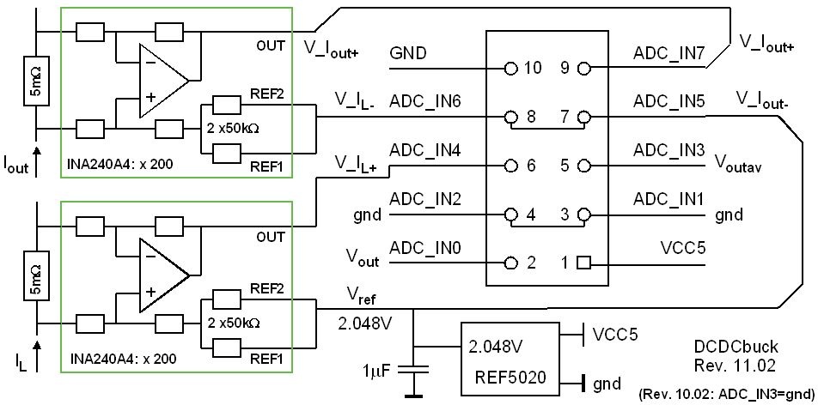

**Fig. 2.3.1.8:** Pin assignment of the 10-pin ADC input plug (connected by the 10 wire ribbon cable). Numbers within the plug-box are the pin-numbers of the plug. Label *ADC_IN#* (# = 1…8) indicates input channel number # of the ADC *LTC2308* [15]. *ADC_IN3* is ground for board revisions *Rev* ≤ 11.01.

Fig. 2.3.1.8 illustrates the pin assignment of the 10-pin ADC input plug (connected by the 10 wire ribbon cable seen in the photo). Numbers within the plug-box are the pin-numbers of the plug. Label *ADC_IN#* (# = 1…8) indicates input channel number # of the ADC *LTC2308*. *ADC_IN3* is ground for board revisions *Rev* ≤ 11.01.

## References

1. *Texas Instruments*, “*LM27222 High-Speed 4.5A Synchronous MOSFET Driver*”, avail.: https://www.ti.com/lit/ds/symlink/lm27222.pdf?ts=1662800602460&ref_url=https%253A%252F%252Fwww.ti.com%252Fproduct%252FLM27222.
2. *Linear Technology (today: Analog Devices)*, “*Low Noise, 500ksps,  
   8-Channel, 12-Bit ADC*”, available: https://www.analog.com/media/en/technical-documentation/data-sheets/2308fc.pdf
3. *Texas Instruments*, “*INA240 – 4-V to 80-V, Bidirectional, Ultra-Precise Current Sense Amplifier With Enhanced PWM Rejection*”, available: <https://www.ti.com/lit/ds/symlink/ina240.pdf?ts=1662820015241&ref_url=https%253A%252F%252Fwww.ti.com%252Fproduct%252FINA240>
4. *Texas Instruments*, “*REF50xx – Low-Noise, Very Low Drift, Precision Voltage Reference*”, available: <https://www.ti.com/lit/ds/symlink/ina240.pdf?ts=1662820015241&ref_url=https%253A%252F%252Fwww.ti.com%252Fproduct%252FINA240>